Login
Sign Up
Logo
Home
Post Yard Sales
Find yard Sales

EVERYTHING MUST GO
Image

Upcoming YardSales (linked to find yard sales)

About US

Contacts
Social Embeds
(Fb. Instagram, twitter)

Logo
(Link to home page)
Home
Find yard Sales
Post Yard Sales

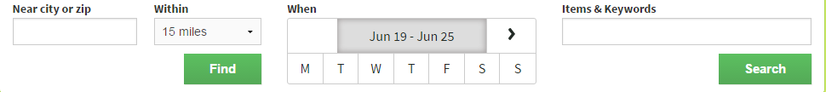
Google Map of Yard Sales
(Linked to all sales)

Ads
Contacts
Social Embeds
Photos
Photos

Exclusive Yardsales
Multifamily YardSales

Bookings only Public Sales
Details of sale, with location
Photos
Details of sale, with location

Go
RSVP
(Linked to form)
Photos

Photos
Go
Details of sale, with location

RSVP
Details of sale, with location

Details of sale, with location

Details of sale, with location

Photos
Go
RSVP

It’s Free
Find yard Sales
Logo
Home
Post Yard Sales

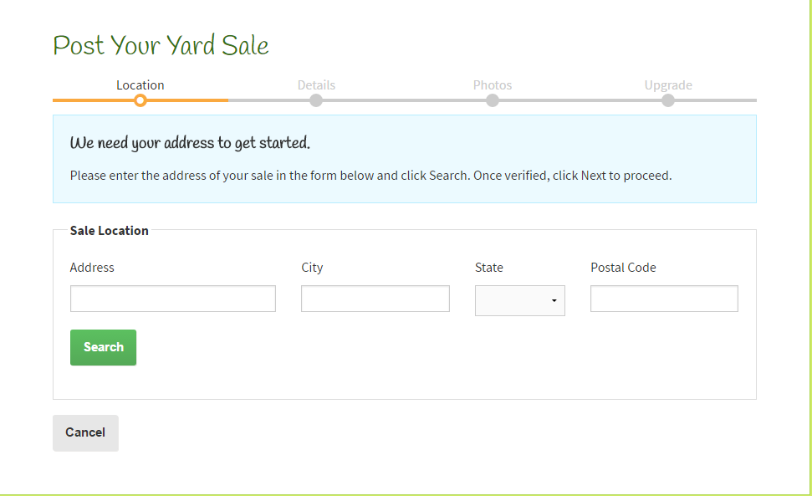

Contacts
Social Embeds

